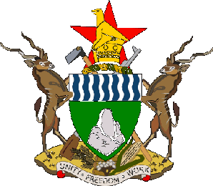
Government of Zimbabwe

National Cultural and Creative Industries Strategy

2020-2030

PART A

Introduction
It is an undeniable fact that world over, Cultural and Creative Industries (CCIs) have become a vibrant sector across the world. UNESCO defines cultural and creative industries as “sectors of organised activity whose principal purpose is the production or reproduction, promotion, distribution and/or commercialisation of goods, services and activities of a cultural, artistic or heritage-related nature.” Since 2000, there has been a significant increase in world trade cultural products, which supports the argument that cultural industries could open the door for African economies to participate effectively in the world market. However, the relatively marginal contribution of Africa (less than 1% according UNCTAD's Creative Economy Report of 2008) to the world export of cultural goods is a reminder that talent alone is not sufficient to build a competitive creative economy and creative industry. The Creative Economy Report of 2010 also notes, “In spite of the sharp increase of African export of creative goods from $740 mln (2002) to $2.2 bln (2008), African creative products are still under-represented in world markets: they are only 0.36% and 0.54% respectively (UNCTAD 2010, p. 130).
The creative industries of Zimbabwe are still in a stage that can be described as infancy but have a potential to boom into a vibrant, well developed industry. In the preface of a research report produced by the Culture Fund of Zimbabwe Trust with support from UNESCO’s IFCD (2012) it is noted that, ‘in Zimbabwe, the cultural industry has, over the past few years, emerged as a source of income, employment and a tool to assert the people’s national identity. The cultural industry contributes immensely in attracting tourist inflows and building the country’s image.’
The demand for access to regional and international platforms for CCIs marketing such as cultural events and festivals is increasing. Over the last ten years a number of new festivals emerged in the country though some have not happened in the last two years due to economic challenged facing the country. Creative industries hubs are also emerging in the cities providing the much needed cultural spaces and access to information and communication technologies (internet) among other services.
The National Trade Policy of Zimbabwe (2012-2016) recognised the critical importance of creative industries, specifically a diversified cultural heritage in generating income. The National Culture Policy launched in 2019 also affirms the importance of creative industries in the country. Creative industries development is one of the policy priorities in the cultural policy document. The Policy is clear that it seeks to harness creative industries as a key driver of economic growth and employment creation in the country, and specifically targets youth, women and other vulnerable sections of the population. This policy is anchored on the principles of strong, sustainable and shared growth and is framed as a building block towards Zimbabwe attaining the Upper Middle Income Society status by 2030. A significant proportion of operators in the CCI are youths and women and this implies that Zimbabwe’s usually marginalised population is inherently positioned to benefit from the implementation of this strategy. Strengthening of CCIs will result in creation of jobs especially for the youths who currently constitute a majority demographic dividend in the country.
Most CCI exist as Small to Medium Enterprises (SMEs). As such, SMEs development has emerged as key instrument in poverty reduction efforts. Therefore, creative industries remain a very strategic sector in Zimbabwe given that most of the people in the sector are self-employed and able to generate incomes from their activities.
It is received opinion that the Arts and Culture sector in Zimbabwe is fragmented, Lack of funding, especially public funding; lack of fit-for purpose infrastructure; weak local markets and lack of access to regional and international markets; less priority in the national development agenda; limited skilled and professionally trained people;, weak legal frameworks to support protection of intellectual property rights- copyright laws are not adequately enforced; limited funding and investment, and weak governing structures.
In addition, the fast-changing and cross cutting nature of the industries pauses challenges for many stakeholders who are critical for their development. The private sector has not yet fully grasped the potential of the sector to increase their support and investment towards it growth. Very little is known about the CCIs contribution towards the nation’s socio economic development. Furthermore, while some creative ventures are inherently entrepreneurial and can generate profits to repay loans, some artistic products, services and activities serve an aesthetic function that cannot be quantified in monetary terms but all the same serve an important social function. This strategy is geared towards increasing the capacity and earnings of the CCIs and their contribution towards the socio-economic development of the country in monetary and social capital terms.
It is against this background that the Department of Arts and Culture Promotion and Development in collaboration with the National Arts Council of Zimbabwe and the National Gallery of Zimbabwe have developed this national strategy for the CCIs in Zimbabwe. The strategy has been developed as a framework to guide strategic investment and foster collaborative partnerships between the central and local governments, arts and cultural organisations and the wider community towards the realisation of these objectives.
Guiding Principles
The philosophy of this cultural and creative industries strategy is underpinned by three guiding principles.

I. Respect for the diversity of cultural expressions, cultural identity, cultural rights and mutual understanding- Zimbabwean values, languages and cultures are acknowledged and respected, rights of creators are recognised and enforced and diverse cultures are safeguarded, promoted and celebrated.
II. Enhance international cooperation and increase opportunities for the local, regional and international communities to engage with Zimbabwean cultural content to encourage mutual understanding, promote economic exploitation of intellectual property and stimulate inclusive economic growth
III. Culture is the key element of sustainable socio-economic development. The role of cultural and creative industries as enablers and a drivers of the economic, social and environmental dimensions of sustainable development cannot be ignored.

The Policy Context
This strategy and action plan has been informed by various national, regional and international policies and instruments which include the following:
- Transitional Stabilisation Programme (October 2018 – December 2020)
- The National Arts, Culture and Heritage Policy
- United Nations Sustainable Development Goals
- Zimbabwe National Intellectual Property Policy and Implementation Strategy (ZNIPPIS) 2018-2022
- National Youth Policy
- Small to Medium Enterprises Policy
- Gender Policy
- Educational policy
- National ICT Policy
- National Trade Policy
- International Conventions and Standard Setting Instruments on Arts and Culture especially the Convention on the Protection and Promotion of the Diversity of Cultural Expressions (2005) and the Convention for the Safeguarding of the Intangible Cultural Heritage (2003)
- The 1980 Recommendation concerning the Status of the Artist
- The SADC Protocol on Culture, Information and Sport 2001
- African Union’s (AU) Agenda 2063
- AU Charter on Cultural Renaissance
- AU Plan of Action on Creative and Cultural Industries
Vision
A sustainable, innovative and vibrant Cultural and Creative industry by 2030.
Mission
To support a flourishing creative and cultural industry that enriches lives, celebrates national identity and cultural diversity.
Goals
This strategy envisages to attain the following goals by 2030:
- Ensure increased visibility of, and access to markets by Zimbabwean CCIs goods and services at regional and international platforms
- Ensure availability of reliable and user friendly data and information on the CCIs including their socio-economic impact.
- Ensure equitable and inclusive access to affordable, fit-for-purpose cultural infrastructure by CCI operators
- Ensure an improved legal and regulatory environment, enforce existing and update outdated laws and promote fairness and ease of doing business of CCIs
- Promote professional, accountable and inclusive institutions and businesses at all levels of CCIs value chain
- Provide and promote quality, professional education and training for CCI operators at all levels of the value chain while stimulating opportunities for innovation, nurturing of talent and professionalism.
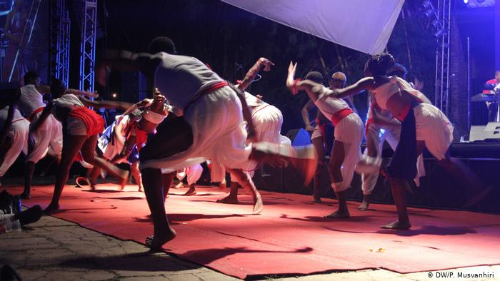
Objectives
The following strategic objectives to be achieved by 2030:
- Identify capacity gaps, develop and implement capacity-building programmes for cultural professionals and staff in public sector institutions and government ministries while supporting capacity building programmes implemented by private players in the sector
- Increase local, regional and international status of CCIs, opening pathways to global marketplaces
- Establish and administer a government funded revolving CCI fund and support investment from funding agencies and the private sector to stimulate the growth of the creative industries
- Provide a national system for generating statistics, documentation and dissemination of information on CCIs and their wider socio-economic impact
- To increase access for cultural workers to equitable professional development opportunities, networking opportunities and the ability to capitalise on new technologies to support innovation
- To increase equitable and inclusive access by CCI operators to fit for purpose infrastructure
- To improve the participation and engagement in CCI activities by Zimbabweans to enhance their social and economic life of the people
- To safeguard and celebrate Zimbabwe’s cultural heritage and strengthen the role of culture in sustainable development

Stakeholders
The successful implementation of this plan of action is hinged on the availability of funding and resources, close collaboration and partnerships between the central government, local authorities and municipalities, other line ministries and parastatals, CCI operators, arts and cultural organisations and their networks, education and training institutions, private sector businesses, diplomatic community, international cooperation partners, and individuals. The Ministry of Youth, Sport, Arts and Culture will work with key stakeholders across the country to identify, review and revise priority projects to be delivered as part of the Action Plan and ensure a strategic and sustainable approach to their development and implementation.
The Strategic Pillars of the CCIs
This strategy has identified the following pillars as critical for the development of CCIs in Zimbabwe:
- Cultural Infrastructure
Cultural infrastructure includes buildings and spaces that accommodate or support the activities of CCI operators including theatres, museums, galleries, open spaces and market places. It also includes the digital and technological infrastructure that enables online access to collections and performances and widens participation and appreciation for all audiences. Currently, local government authorities own and operate most of the key cultural infrastructure and cultural facilities across the country. Strong relationships between the CCI operators and local governments are critical to the successful and equitable delivery of arts and cultural services and infrastructure in the country. Equally important to this sector are private players and individuals who own cultural spaces and hubs. Diplomatic communities also have cultural centres which are crucial in the CCI value chain. Fit for purpose cultural infrastructure, well-resourced and maintained is essential to providing support for arts development.
Priorities
- Creating an inventory of existing cultural infrastructure including that owned by individuals and private players
- Increasing access to spaces by local, regional and international visitors and audiences
- Improving access by marginalised populations- women, young people and the disabled to foster equitable opportunities for the citizens to enjoy and benefit from cultural experiences as artists and audiences
- Keeping cultural institutions up to date and fit for contemporary purpose, including digital resourcing.
- Renovating, modernising and upgrading the State owned Cultural Infrastructure.

- Funding, Financing and Investment
Currently there is lack of direct government funding to support creation, production and distribution of cultural goods, activities and services. This is despite the recent renewed interest by the government to establish an Arts Development Fund through the National Arts Council of Zimbabwe. Owing to lack of capital as a result of lack of direct financial investment both by the government and private sector, optimum cultural production will remain constrained across the creative value chain. In addition, donor funding for the creative sector lacks cohesion and many funders tend to operate outside and without any guiding, or long-term policy frameworks – in terms of cultural development. If there are guiding frameworks, these are more likely to be determined by the funding partner or by that institution’s country head office than by national priorities for Arts and Culture in Zimbabwe (Eveleigh, 2013, p7). It is a fact that the current macro-economic context of the country is not favourable for doing business. The arts, culture and heritage sector does not exist in a vacuum but in a broader economic context. Without addressing fiscal and current deficits, CCI operators will be hamstrung to produce goods and services and consumers will have no capacity to consume the limited cultural products and services. There is a direct causative relationship between macro-economic stability and cultural vibrancy.
Priorities
- Partner with key stakeholders to research and identify funding opportunities for the creative industries.
- Establish a government supported CCI development Fund.
- Put in place appropriate legislation to provide fiscal incentives to artists, cultural producers and investors in the CCIs, especially the corporate sector.
- Establish microfinance schemes for creative enterprises which accept intellectual property as collateral.
- Engage development partners to provide systematic funding to the sector
- Local authorities should have a sound and real budget on CCIs

- Education, training and capacity building
Cultural operators need platforms and funding to be able to acquire and develop entrepreneurial, creative, technical, technological and managerial skills and competencies. The CDIS report (2018) notes that the education system in the country has provided for a varied and coherent range of training at various levels in the field of culture, covering technical, vocational, secondary and tertiary levels of education. This includes training courses at different levels in performing arts, heritage; music; fine, visual and applied arts; cultural management; and film and image. It is important to note that practical and technical education in areas such as cultural management is still lacking in Zimbabwe. Diverse mentorship and informal education and training has been implemented by various institutions and individuals but most of it goes unnoticed because those offering the training are not accredited with the responsible ministries.
Priorities
- Fostering economically productive innovation and skills development, including digital capacity and education.
- Implement cultural and creative entrepreneurship training
- Provide capacity-building and training programmes formally and informally at all levels of the value chain.
- Accreditation of informal training programmes for recognition locally and internationally
- Ensure artists have access to schools, technical vocational institutions and tertiary institutions to collaborate with leaners and teachers.
- Provide infrastructure, equipment and ICTs for practical CCIs education.
- Staff development for trainers and teachers
- Encourage practice around emergent creative forms in CCIs such as digital arts.
- Establish government and support private owned internationally recognised training facilities and schools

- Cultural Statistics and research
The importance of generating cultural statics and research on CCIs cannot be overemphasised. The first local effort to generate cultural statistics was when the Culture Fund of Zimbabwe Trust in partnership with ZIMSTAT conducted a Culture Statistics Survey with support from UNESCO in 2012. This study focused on Harare and its surrounding areas of Chitungwiza and Norton and utilised the UNESCO Culture Statistics Framework (2009). In addition, the Zimbabwe National Statistics Agency (ZIMSTAT) also showed its support for the production of culture statistics by setting a culture unit within it in 2012. In 2017-2018, Zimbabwe, with technical assistance of the UNESCO Regional Office for Southern Africa, began implementation of the CDIS and generated critical statistics.
Although there has been a major gap in the generation of national information on the CCIs in Zimbabwe (One glaring gap has been the inability to measure aspects such as cultural participation yet these studies are critical for evidence-based policy-making), numerous organisations have generated crucial data through concerted efforts.
Priorities
- Include the creative industries among the priorities in national development plans.
- Organise conferences and debates to engage CCIs operators, policymakers, citizens and some key stakeholders on CCIs on critical issues affecting the sector
- Build Capacities of the National Statistics Agency and CCI Operators on collection of Cultural Statistics.
- Mapping information and baseline data for the CCIs
- Produce up to date data and info graphics reflecting the cultural sector's direct economic impact on national GDP.
- Produce up to date data and info graphics reflecting the cultural sector's value and contribution towards national development
- Advocate for use of socio-economic impact of culture data in national development plans, national budgets and programming for government and national development partners.

- Media, Information and Communication Technologies
The media presents a strong platform for promoting CCIs but currently both the mainstream and online media content remains focused more on political issues leaving CCIs at the periphery. Arts journalists’ capacity to deeply engage with CCIs remains weak.
Advances in technology and communication may offer CCIs the opportunity to develop markets and networks beyond their current scope, enhance production and diversification of products. Technology offers opportunities to expand audiences and make cultural experiences more accessible to more people in spite of the location and time of the day. There are already some private organisations and hubs facilitating the use of the digital space in the major cities of Zimbabwe. According to the CDIF analytical brief (2018) in 2014, 68% of the population in Zimbabwe used the Internet. Despite the recognition of the key role that access to digital technologies, in particular the Internet, plays in boosting the economy and encouraging new forms of access, creation, production, and the dissemination of ideas, information and cultural content, Zimbabwe has a fair result on internet use. This result may reflect the need to increase investment in the development of infrastructures, policies and measures that facilitate the use of new technologies. The country may also need to address issues such as pricing, bandwidth, skills, public facilities, content and applications targeting low-end users in order to bring more people online. Lack of digital skills could also be one of the huddles for full embracing of digital technology.
Priorities
- Build the capacity of media on the coverage of CCIs
- Engage media to lead in profiling CCIs locally, regionally and internationally and raising awareness on the importance of CCIs to policy makers
- Reduce access barriers for using ICTs among CCIs which include lack of the basic infrastructure for ICT access, high costs of data etc
- Address ICT skills and capacity gaps
- Facilitate systemised, ongoing professional education and training to enhance ICTs technical skills for CCI operators
- Development of new business models to match these new opportunities presented by ICTs for cultural content, creation, access, and distribution.
- facilitate the inclusion of excluded and minority groups such as rural populations and women
- facilitate for regulation of the cyberspace to protect CCI operators from threats such as Cyberbullying
- stimulate creativity and innovation through collaborative platforms for ICTs practitioners and CCI operators
- Digitize cultural content to preserve it for future generations (eg. digital libraries and museums) and facilitate engagement of marginalized groups to be engaged.

- Cultural Governance
Cultural governance is a complex topic in Zimbabwe. CCIs currently fall under several ministries and coordinating the work and programmes of those ministries is a huddle. The government and public institutions responsible for CCIs have made effort to work in consultation with CCI institutions, civil society and individuals in conceiving and implementing most of its programmes geared towards strengthening CCIs. CCI operators have also raised issues around a rugged regulatory environment punctuated by too many different government departments suggesting that a ‘one stop shop’ would serve them better.
Although there are some strong CCI institutions operating locally and globally, the sector has largely suffered from weak institutions. Creative businesses mostly operate in the informal sector and face challenges in areas such as records keeping, management among others.
Outdated Acts of Parliament governing CCIs, including the National Gallery Act and the National Arts Council of Zimbabwe Act need to be urgently amended and aligned to the Constitution (2013). The ease of doing cultural and creative business is currently affected by the economic challenges faced by the country in general.
Moreover, cultural policy is centrally managed with very minimal participation of local authorities and municipalities. It is clear that the government has accepted that decentralisation is a key strategy for fair and just governance and this principle should also be applied to the CCI sector.
Cultural rights are another crucial aspect of cultural governance. CCIs thrive when the operational environment enables them to create, produce and disseminate work to the consuming public without too many huddles. Respect and protection of artistic freedom as a subset of human rights is central to vibrant creation, production, distribution and access to cultural goods, products and services but this is not to be abused by creative.
In terms of ratifying regional and international instruments, Zimbabwe has made much effort to ratify key international legal instruments affecting cultural development, cultural rights and cultural diversity, as well as to establish a national framework to recognize and implement these obligations.
Priorities
- Strengthen governance of existing private and public cultural institutions
- Review and update all outdated Acts of Parliament governing the CCIs
- Recognise and optimise the overall contribution of the CCI to economic and social development
- Implement of the National Arts and Culture Heritage Policy and measures that nurture and strengthen creativity
- Establish legal, regulatory and/or institutional frameworks necessary to develop the culture sector
- Continue to ensure involvement CCI operators and civil society engagement in all government programmes for the development of CCIs
- Facilitate the elaboration and implementation of sector specific policies and measures eg Film Policy, Music Policy etc
- Review governance framework and mechanisms designed to create favourable environments for the emergence of dynamic cultural sectors and the promotion of cultural vitality

- Cultural Diplomacy and Global Business
Cultural diplomacy is a critical area that plays a significant role in nation building, enhances the reputation of Zimbabwe as a culturally rich and diverse society and influence perceptions of the international community and Zimbabwean at home and abroad about the country. Cultural and Creative industries have a huge potential to support Zimbabwe’s brand development at the global stage. Any strong and sustainable brand development programmes implemented by the government must include Creative and Cultural Industries (CCIs) as these are the institutions that generate soft power through cultural products- soft power which gets projected to the rest of the world through electronic and digital media. Extra-territorial cultural expression is inherently an expression of a nation’s soft power.
Priorities
- Support and promotion of the creative industries internationally as part of the “Zimbabwe is Open for Business” philosophy
- Establish networks; and support ongoing collaborations and exchange as a way of projecting a positive image about the country
- Project a positive image about the country, celebrate our core values of Ubuntu and promote the country and its cities as innovative, creative, culturally diverse and tolerant; and as an attractive place to live, work, study, and invest.
- Enhance markets and develop export opportunities
- Promoting international cooperation to facilitate the mobility of artists as well as the flow of cultural goods and services
- Include CCI in all international trade agreements and implement the provisions of the agreements.

- Safeguarding Cultural Heritage, Identity and Celebrating Diversity
Zimbabwe’s national arts, culture and heritage policy acknowledges the role that cultural identity and diversity play in sustainable development hence the need to preserve them. UNDP notes that experience proves that the acknowledgement of cultural heritage in the design and conduct of development policies is key to the active participation of communities and to the effectiveness of programmes in the longer term. The United Nations 2030 Agenda for Sustainable Development clearly acknowledges, for the first time, this crucial role of culture as an enabler for sustainable development and mutual understanding. It is also clear that while some creative ventures are inherently entrepreneurial and can generate profits some have an intrinsic value that cannot be quantified in monetary terms but all the same serve an important social function.
Priorities
- Promoting the Zimbabwean cultural identity, respect for cultural diversity and intercultural dialogue for social cohesion
- Awareness-raising on the importance of living heritage, community-based inventorying and elaboration of nominations files to the lists of the 2003 Convention.
- Stakeholder sensitisation workshops, engagement and mobilisation of traditional leaders and communities on the role of culture in sustainable development.
- Cultural heritage commemorations events.
- Tangible and Intangible Cultural Heritage Awareness raising campaigns.
- Creation of Inventories for Intangible Cultural Heritage
- Research on Intangible and Tangible Cultural Heritage
- Promoting and preserving local languages

- Intellectual Property (IP)
Intellectual property rights in Zimbabwe are enshrined in the Copyrights and Related Rights Act. Zimbabwe recently adopted a National Intellectual Property Policy and Implementation Strategy (ZNIPPIS) 2018-2022. IP Rights are mostly enforced by the Ministry of Home Affairs which is largely responsible for law enforcement. The location of ARIPO in Zimbabwe makes IP technical assistance readily available. However, CCI operators are affected by rampant piracy. Just as in most African countries, Zimbabwean copyright societies are weak. African copyright societies have been collecting less than one percent of global copyright royalties over the past two decades. This is as a result of inadequate legislative and institutional frameworks, resistance to copyright compliance by users, weak enforcement, limited recognition of copyright based industries as vital contributors to economic growth and GDP by policy makers (African Union Plan of Action on Cultural and Creative Industries).
Priorities
- Cub piracy
- Enforce existing legal instruments for the protection of IP rights
- Raise awareness among creators on IP rights
- Encourage creators to register their works for protection
- Capacitate copyright societies to effectively collect royalties
- Raise awareness on the bad effects of piracy to the general public.

- Cultural markets and business development
Currently, the value of Zimbabwe’s creative industries exports is not known but with global demand for creative exports rising, there is opportunity to reach international markets. Alongside expanding market, engaging internationally fuels creative inspiration, collaborations and a positive image of the country Activities such as international touring, trade shows, cultural exchange, residencies and showcase opportunities, can deliver more audience and marketplace exposure, connections for CCI operators and extend the life and impact of their work. At international level, cultural and creative industries operate in a global context. Globalisation present both opportunities, competition and threats to creative products and services in Zimbabwe hence the need to improve product quality and competitiveness.
Locally, the market challenges faced by the sector can be attributed to economic challenges facing the country. The arts, culture and heritage sector does not exist in a vacuum but in a broader economic context. Without addressing fiscal and current deficits, CCI operators will continue to face challenges to produce content and consumers will have no capacity to consume the limited cultural products and services. There is a direct causative relationship between macro-economic stability and cultural vibrancy.
Priorities
- Provide access for creators to participate in domestic and international marketplaces where their artistic works/expressions can be recognised
- Organise interface platforms between tourism, the media and creative industries to facilitate partnerships and collaborations.
- Endorse arts and culture events and festivals and ensure government presence at these events
- Encourage innovation and development of new industries away from the traditional CCI forms (such as music and performing arts) focusing on contemporary art forms that are commercially viable locally, regionally and internationally
- Organise export promotion and markets development programmes improve coordination and develop commercial opportunities in related areas such as tourism
- Enforce bilateral, multilateral agreements and instruments such as the Preferential Trade Area (PTA) for Eastern and Southern Africa and the African Continental Free Trade Area to enhance mobility of CCI operators
- Establish an online platform for sharing of information, opportunities and networking for creative entrepreneurs.
- Strengthening production and distribution infrastructure/networks for creators
- Undertake business development activities to support new and existing creative organisations and micro businesses.
Cross Cutting Issues
- Youth Participation
CCIs are anchored on the principles of sustainable inclusive growth which can contribute towards Zimbabwe attaining the Upper Middle Income Society status by 2030. Realisation of this vision partly entails creation of jobs for the youths who are a majority demographic dividend. Zimbabwe is an extremely young country, with 62% of the population below the age of 25 years (UNFPA). According to the National Association of Youth Organisations 90% of youths in the country are unemployed including university graduates. It is a fact that a significant proportion of operators in the CCI are youths and this means young creatives are inherently positioned to benefit from this strategy.

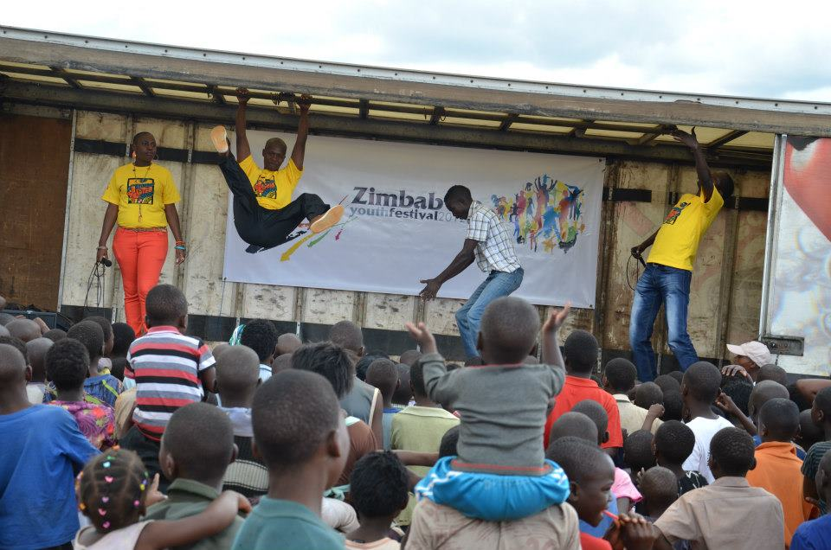
© Zimbabwe Youth Festival
CCIs present an opportunity that, if optimally harnessed, can redress some capital constraints faced by youths in the country. Youth empowerment interventions that are aimed at unlocking entrepreneurial value of youths as a strategy for employment creation and income generation will definitely benefit the country. Currently, the youth artists feel distant from the markets due to both lack of information, technology and a lack of structured markets, incremental skills building in art as a business, poor connections to and knowledge of ICT and little participation and influence in the wider creative economy as young people.
- Gender Equality
Although women in Zimbabwe constitute more than 52% of the population, their socio, political and economic conditions are undesirable. Gender inequality across the entire sector is a major issue. The Baseline Study on the Culture Sector in Zimbabwe (2009) revealed that women in the sector in comparison to men; play less influential roles in various establishments. 10-15 % of the art and culture establishments are led by women (Status of Women in the Arts Study by Culture Fund of Zimbabwe Trust, 2015). Goal 5 of the SDGs seeks to achieve gender equality and empower women and girls. UNDP notes that it’s proven that empowering women and girls helps economic growth and development. This CCI strategy targets to strengthen the socio-economic position of women and contribute to women empowerment through employment creation.
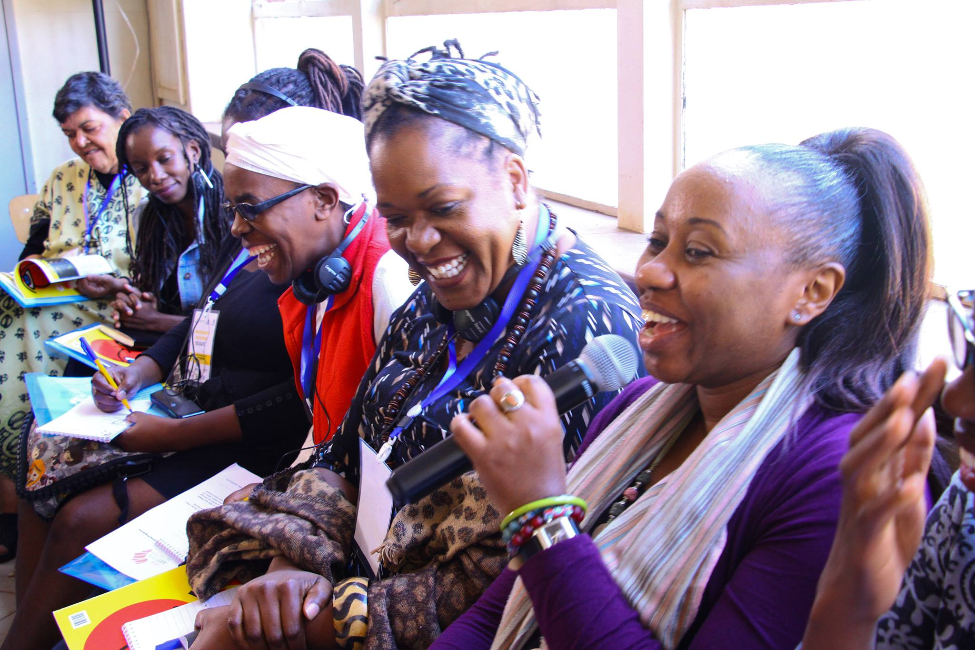
© Arterial network Zimbabwe
- Disabled CCI Operators
This CCI strategy expands the scope of the rights of disabled artists and their institutions to artistic expression, opportunities to participate in CCI work, enjoy arts and culture by supporting their creative activities. The government pledges to guarantee the inclusion and participation of disabled artists in CCIs by providing them with opportunities presented by programmes implemented around each of the ten pillars of the CCIs.

PART B IMPLEMENTATION MATRIX, MONITORING AND EVALUATION

http://www.unesco.org/new/en/santiago/culture/creative-industries/
The Culture for Development Indicators (CDIS) demonstrate the enabling and driving role of culture in sustainable development. The tool examines, through facts and figures, the multidimensional relationship between culture and development.
Culture Fund baseline survey 2009, Culture Fund Gender Study 2012, British Council study on Participation of young people in the arts in Harare and Bulawayo among others
Examples include Stimulus, Batanai2Create, TechHub, Impact Hub, Moto RepubliK among others

